Risk Management Plan

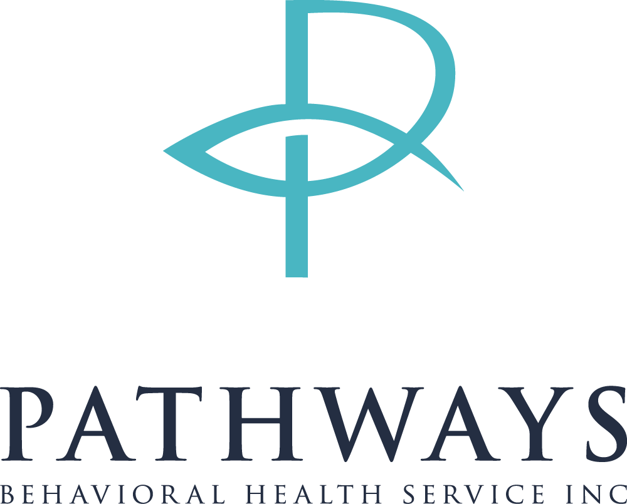
594 Halls Creek Rd
New Bern, NC 28560
Phone: 252-745-5761
Fax: 252-745-770
www.pbhsinc.com

The goal of the Pathways Behavioral Health Service Inc’s (Pathways) Risk
Management Plan is to “Promote Quality Services and Manage Risk Effectively”. Pathways is to protect itself against accidental loss or losses which would significantly affect
the Pathway’s clients, personnel, property, budget, or its ability to continue to fulfill its
responsibilities.
It is Pathway’s policy for every employee to act to reduce risk of accidental loss or
injury to the greatest extent feasible, consistent with carrying out Pathway’s mission of
honoring God by creating an atmosphere of teamwork, optimism, and honesty to help any one with a disability achieve a greater quality of life, while recognizing that for every
individual there is a right to experience life and take risk.
To accomplish the goal of effective management of risks, areas of exposure are identified
and tracked by the Director with help of other administrative staff
Risk management includes actions taken before and after a loss occurs and is directed
towards reducing risks and reducing the frequency and severity of losses. When
analyzing a loss exposure and its treatment the impact on Pathways, as well as the
individual area evaluated.
Pathways is exposed to many risks in the course of daily operations. Most fall into one
of the following categories:
• General Liability
• Professional Liability
• Employee Liability
• Liability to Persons Served
• Property Loss
• Vehicle Related Loss
• Contractual Liability
• Loss of Reputation

Pathways utilizes various methods to manage risk as outlined in the Risk Management
Control System Grid. The Director is responsible for the annual review and
upkeep of the system.
Risk Avoidance
Pathways may elect to avoid undesirably high risks by refusing to undertake.
business ventures that are unsafe and unsuitable for employees and clients.
Loss Prevention and Loss Reduction
Risks inherent in the existence and operation of Pathways can be reduced,
resulting in a decrease in both frequency and severity of accidental losses. It is
the responsibility of each employee to conduct business in such a way as to reduce or prevent
hazards to individuals and property and to evaluate the risk cost potential when developing new
programs.
Risk Retention
It is the policy of the Pathways to retain the financial responsibility for its risk of
accidental loss to the maximum extent possible without jeopardizing the financial
positions of Pathways or the continuation of essential programs.
Risk Transfer
The financial responsibility for risks may be transferred to others through
contractual agreement or through the purchase of insurance. Pathways will
maintain insurance at appropriate levels; however this does not alter the
responsibility of Pathway’s personnel for compliance with required and
appropriate safety and security standards.

Pathways Risk Management Controls System
Goal: TO PROMOTE QUALITY SERVICES AND MANAGE RISK EFFECTIVELY. Risk Management Plan incorporates systems of checks and balances that clearly define accountability and monitor critical performance variables. Control systems are designed to minimize risks and prevent and detect illegal or unethical activity and or fraud, waste and abuse. Access to critical information is on a need to know basis.
General Liability
General liability refers to the amount of loss payable to others outside the agency for injury or damage arising from operations. It applies to personal injury, bodily injury and property loss or damage to a third party resulting from the negligence of the program operations or the employees.
Pathways manages general liability risk by maintaining general liability insurance. Pathways reviews insurance annually with the insurance broker for adequacy of coverage and limits.
In addition, Pathways is present at annual inspection of UAFL homes to discuss safety issues and limit risk. The Director is responsible for:
• Establishing procedures for handling suggestions and recommendations by Trillium Health Resources
• Conducting regular systematic workplace inspections to discover and report unsafe conditions and practices.
• Review circumstances and causes of accidents and recommend corrective measures.
• Develop and revise rules, policies or procedures to comply with all current safety and health standards.
• Monitor and evaluate all safety related drills.
• Promote and champion all safety training to employees.
Pathway’s overall goal is to make every area a safer work environment.
Exposure | Control Mechanism | Responsibility | Review Date | Status Report
Employees and clients with disabilities and behaviors , out in the community  - Behavior can escalate, causing harm  - General administrative litigation risks  - Medical needs | - Close supervision of clients by employees  - Orientation training  - Liability Insurance  - Crisis Training  - CPR Training | - Director  - All Staff | Staff must report a crisis immediate to supervisor  Meetings  Annually at renewal  Annual training | Minutes recorded  Insurance policy current  Training documentation
Professional Liability
Liability is most prevalent in areas of hiring, treatment and termination of employees. In terms of Directors, QP and CEO liability, consumers and guardians rightfully expect a high level of character, professionalism and ethical conduct. Directors, QP and CEO must exercise reasonable care in diligence in carrying out their tasks. Negligence in fiscal management is the most common target of Directors and CEO liability. Failure to comply with the Americans with Disabilities Act (ADA) opens yet another arena for possible liability exposure.
Pathways manages professional liability risk by maintaining professional liability insurance. Pathways reviews insurance annually with the insurance broker for adequacy.

Exposure | Control Mechanism | Responsibility | Review Date | Status Report
Pathways has financial assets. All financial information is maintain by our book keeper and company CPA. | - Duties are strictly implemented  - 2 signatures required for checks  - CEO approve expenditures | Director  CEO | Ongoing purchases approve when needed  All financial reports approved by Director or CEO | Minutes
Hiring, treatment, and termination of employees | - Positions are approved by Director  - CEO authorizes hiring and termination | Director  CEO | Each payroll period | Minutes

Liability to Employees
Pathways liability to its employees includes compensation for job related accidents or occupational illnesses. Three types of loss exposure are workers compensation claims, employer liability claims, and non-compliance with applicable occupational safety and health regulations.
Pathways manages employee liability risk by maintaining workers compensation insurance and safety committee meetings. Pathways reviews insurance annually with the insurance broker for adequacy.
Exposure | Control Mechanism | Responsibility | Review Date | Status Report
Employees who work for Pathways are exposed to various occupational accidents  - Employees being injured by a client  - Straining back while lifting | - Review on injury/accident reports to determine trends and methods  - Ongoing employee safety training | Director  Employees | Annual employee training  Reports from employees | Injury/Accident reports
Exposure to hazardous and infectious diseases | Pathways emphasizes and trains workers on universal precautions | Director | Annually | Ongoing, Employees sign communicable disease form

Liability to Persons Served
Pathways is responsible for the mental, physical and fiscal health of its clients
Exposure | Control Mechanism | Responsibility | Review Date | Status Report
Administrative litigation on abuse and neglect. Due to the variety of cognitive and physical disabilities served, staff member have encountered liability risk while performing their duties. | - All incidents are reported in accordance with Pathways Reporting  - Proper staff to client ratios are maintained  - Staff receive crisis intervention training | Director  Staff  QP | Quarterly Review of incident reports  Trends and patterns reviewed annually | Annual reports

Property Loss
Physical property at risk includes real and personal property of Pathways, employees and clients. The loss may be a result of accident or theft. Property may be destroyed, damaged or lost, causing an interruption in normal operations.
Pathways manages property loss by maintaining insurance
Exposure | Control Mechanism | Responsibility | Review Date | Status Report
Pathways office has smoke detectors through out  UAFL homes have smoke detectors as well | - Safety inspections  - Safety Drills | Director  QP | Ongoing, as needed  At least annually | Drills

Vehicle related loss
Risks include property damage to the vehicle itself, in addition to liability claims for personal injury and property damage as a result of vehicle accidents. Pathways employees may transport clients to community outings. Vehicle insurance is held on vehicles and background checks/driving records are required for employees who transport clients.
Exposure | Control Mechanism | Responsibility | Review Date | Status Report
Vehicles are maintained on a schedule | - All vehicles have a first aid kit  - Employees put submit insurance information when they renew it | Director  Staff | Annually | Internal checklist

Contractual Liability
When risk is contractually transferred form one party to another, loss exposures can be increased or decreased. Contractual liabilities can arise out of leases, rental agreements, special service agreements, joint use agreements, cooperative adventures, and contractual labor.
Contractually liability is managed through indemnification clause within contracts.
Exposure | Control Mechanism | Responsibility | Review Date | Status Report
Risk transfer through contractual relationships | Indemnification clauses  Legal review | Director | On going | CEO approval

Business Loss / Interruption
Loss or reductions of funding and major losses of facilities all create risk. Risk is managed through long range planning and budgeting.
Exposure | Control Mechanism | Responsibility | Review Date | Status Report
Changes in funding would impact Pathways services long term and business stability | Strategic planning  Financial planning | Director  Bookkeeper | On going | Strategic plan  Financial Reports

Loss of Reputation
Loss of reputation could result from negative publicity arising from negligent or unethical behavior of staff and/or organization. Loss of reputation is managed through the long-range planning.
Exposure | Control Mechanism | Responsibility | Review Date | Status Report
- Loss of CARF accreditation,  - Licensure by state of NC  - Abuse/Neglect by staff  - Negative press | - CARF Accreditation  - Passing state inspections  - Staff training  - Media policy | Director  All staff | Annually  Ongoing | CARF Certification  State license  Surveys

The Pathways administrative team met on November 20th, 2020, virtually, to review and discuss the Risk Management Plan. All areas of the plan were reviewed and updated as needed. In addition, during 2020 the Director implemented a Pandemic Response Plan in response to the pandemic that hit earlier in the year to mitigate risk.

